Lab1: 5TC -> 1TS

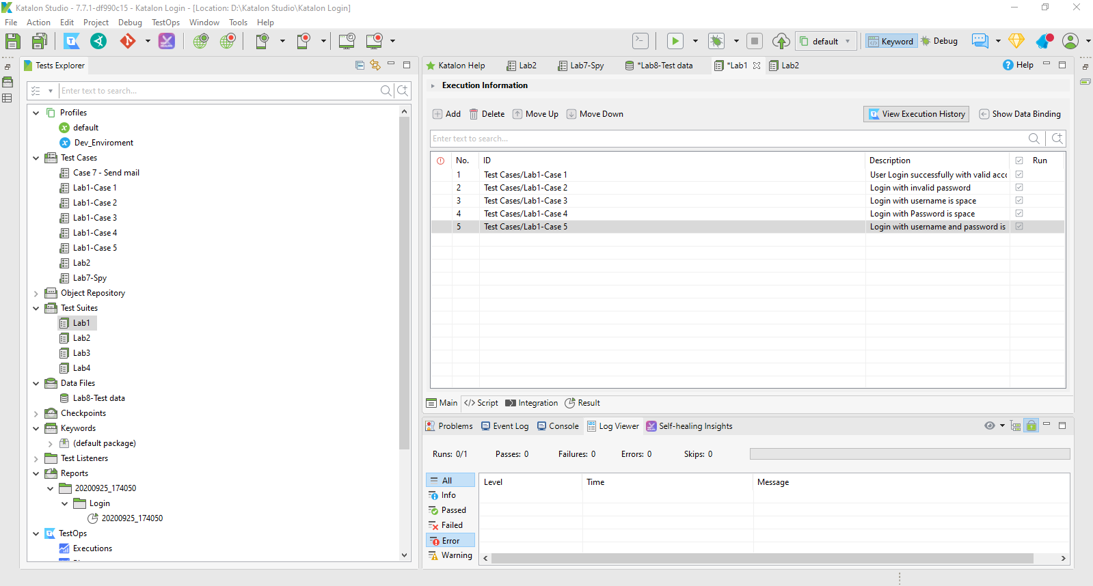

Lab2: Verify & Wait

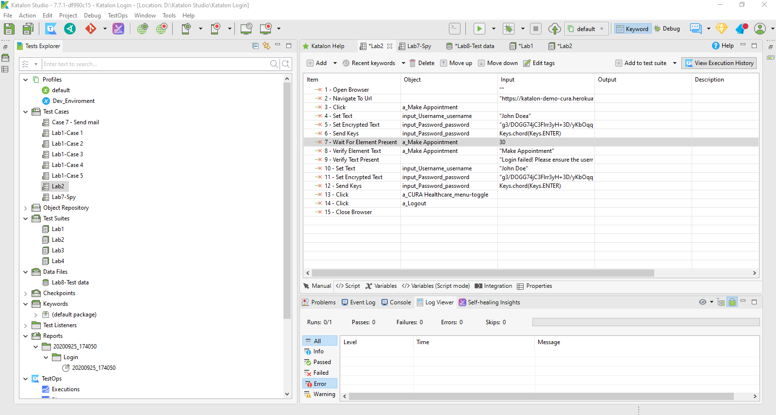

Lab3: G Sheet

<https://docs.google.com/spreadsheets/d/1QZpIye7y6rQUeGlWcuFDNFdIettGcX_l8Ma7YhEtiIQ/edit#gid=0>

Lab4: Profile

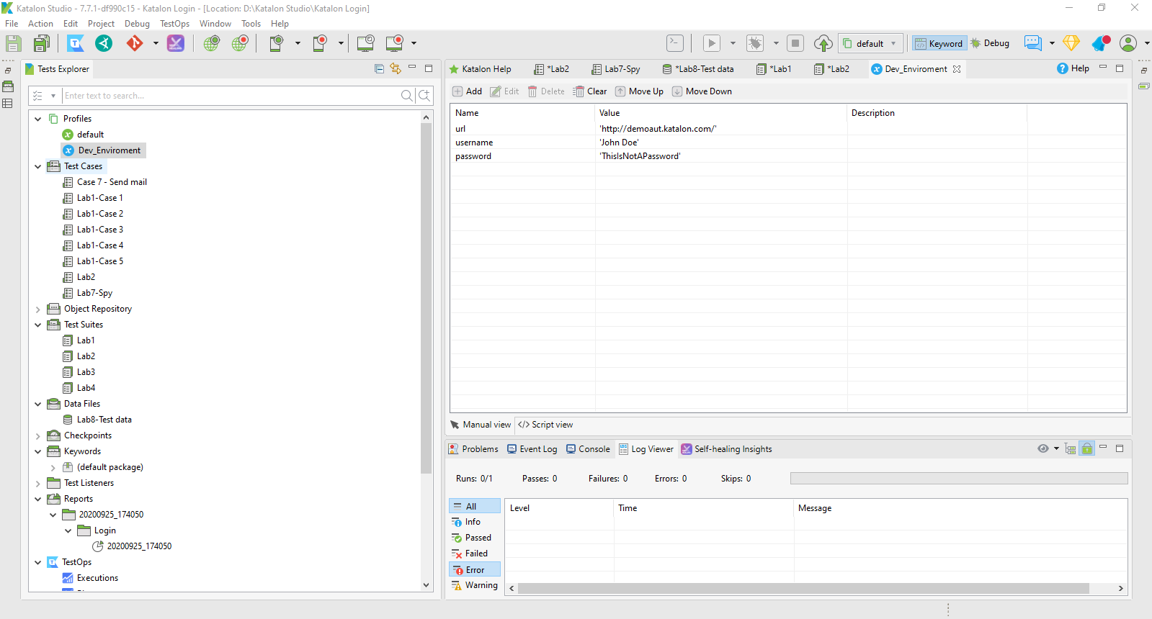

Lab5: send mail

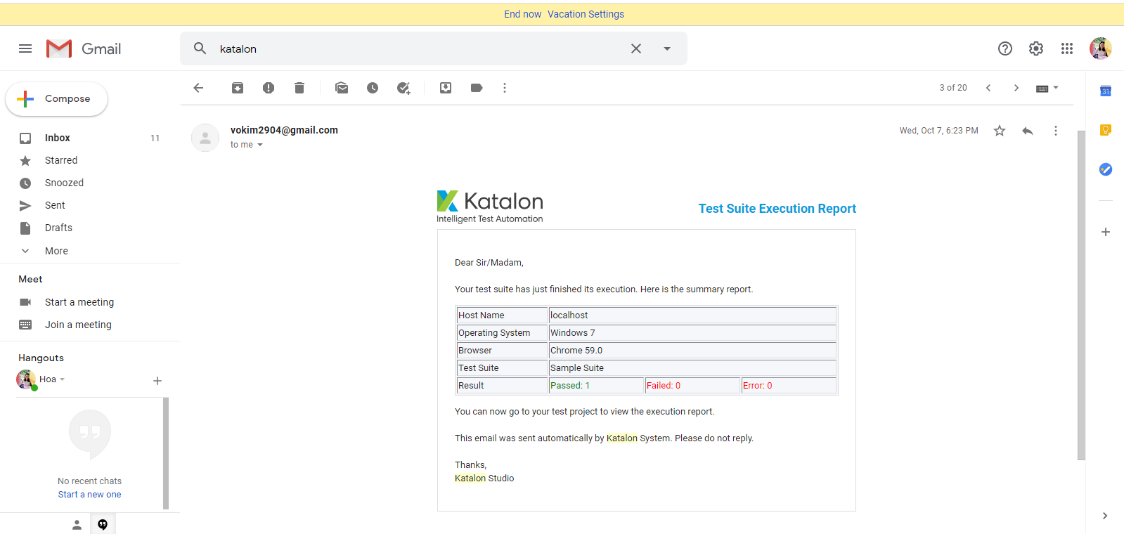

Lab6: Export Report

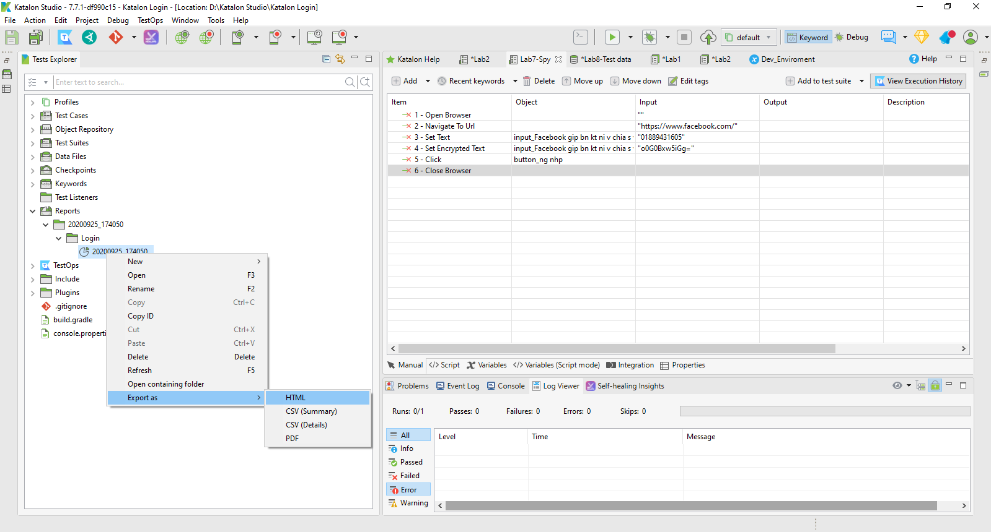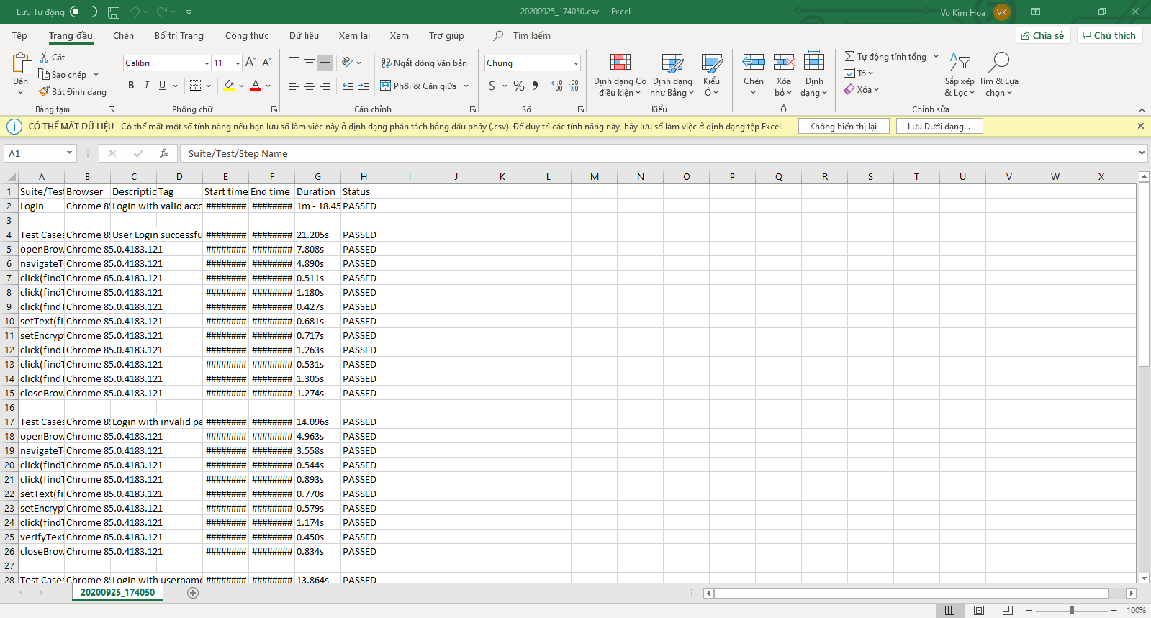

Lab7: Spy

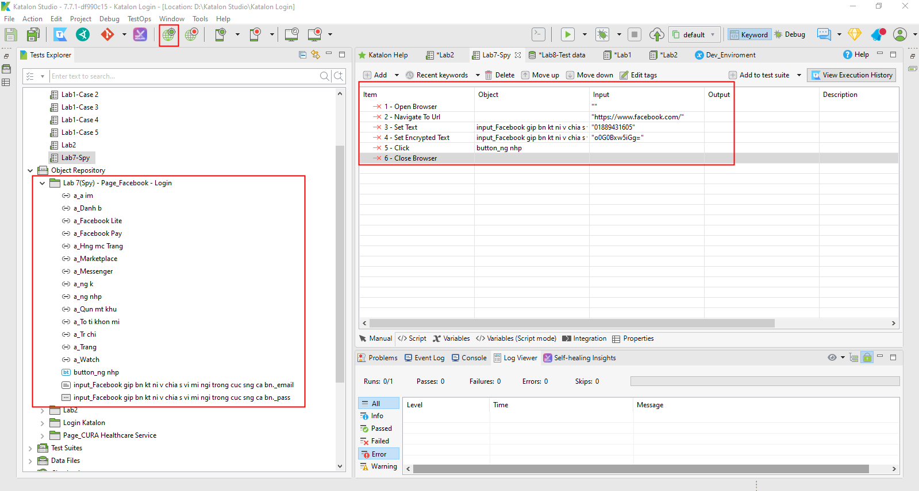

Lab8: Add data file

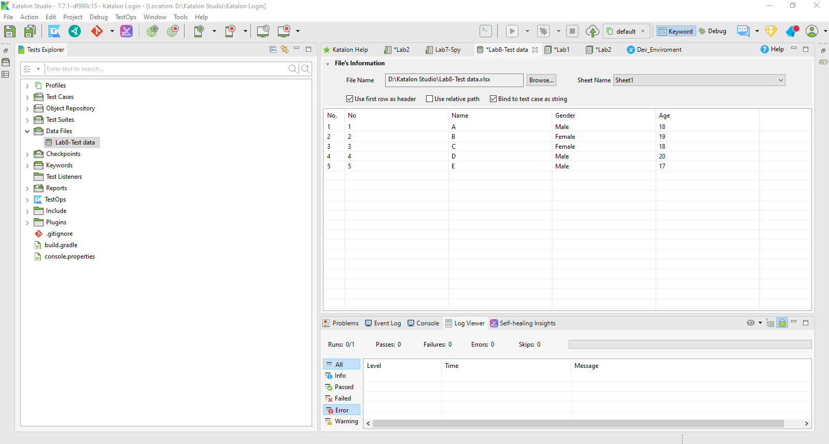

Lab9: Bug Report

<https://docs.google.com/document/d/1q2-gY1jxvIuMtBT0G789ipEJPbUAt_H-H7AsePa4Mw4/edit>

Lab10: Manual Script

|  |  |  |  |  |  |  |  |  |
| --- | --- | --- | --- | --- | --- | --- | --- | --- |
| **Test ID** | **Test Name** | **Subject** | **Designer** | **Creation Date** | **Type** | **Description** | **Test Step** | **Excepted result** |
| **TC001** | Shows 0 Students | New | **Vo Kim Hoa** | 14/10/2020 | Manual | The list show no Student | 1.Click on print button | Success and The list show no Student |
| **TC002** | Shows 1 Students | New | **Tran Tan Dat** | 14/10/2020 | Manual | The list show 1 Student | 1.Input n = 1  2.Click on print button | Success and The list show 1 Student |
| **TC003** | Shows 2 Students | New | **Vo Kim Hoa** | 14/10/2020 | Manual | The list show 2 Student | 1.Input n = 2  2.Click on print button | Success and The list show 2 Student |
| **TC004** | Shows 25 Students | New | **Tran Tan Dat** | 14/10/2020 | Manual | The list show 25 Student | 1.Input n = 25  2.Click on print button | Success and The list show 25 Student |
| **TC005** | Shows 44 Students | New | **Vo Kim Hoa** | 14/10/2020 | Manual | The list show 44 Student | 1.Input n = 44  2.Click on print button | Success and The list show 44 Student |
| **TC006** | Shows 45 Students | New | **Dinh Viet Khoi** | 14/10/2020 | Manual | The list show 45 Student | 1.Input n = 45  2.Click on print button | Success and The list show 45 Student |
| **TC007** | Shows 46 Students | New | **Dinh Viet Khoi** | 14/10/2020 | Manual | The screen show notification error | 1.Input n = 46  2.Click on print button | Failed and Notification Error |